CM2020 Agile Software Projects – Final report

**SpaceWise**

A web-based seat and study room reservation system for libraries and co-working spaces

Authors: Jones Ullagaddi, Zachary Brown, Indu Singh, Roy Mattar

Revision: 02

University of London

BSc (Computer Science)

2024 October Team11 Tutor Group 5

Table of Contents

Abstract 5

Outcome 5

Introduction 5

Aims and Objectives 6

SMART Aims 6

Objectives 6

Data travel – Overview 7

Network Connectivity Diagram 7

Planning and Research 8

Resource and time allocation 8

Frontend 9

Type of Frontend 9

Tools used for the Frontend 9

Size of every single screen 9

Color scheme used for the user interface 9

Font used for the Frontend 10

Sequence of the screens 10

Logic behind the screen 10

Backend 12

Tools used for the Backend 12

Size of screen 12

Color scheme used for the user interface 12

Database Tables 13

UML – Table relations 14

REST – API pseudo code 15

Interface Diagram of Frontend and Backend modules 19

User Experience (UX) 20

Testing of SpaceWise 21

Whitebox testing 22

Blackbox testing 23

References 25

Appendix – Meeting logs 26

**Table of Figures**

Figure 1 Network Connectivity diagram 7

Figure 2 UML representation of relationship of Tables 14

Figure 3 Interface Diagram of FrontEnd and BackEnd modles 19

# Abstract

This project is a tool which allows users to reserve their library seat. This tool runs as app for anyone with a Phone / Tablet / Laptop. Users will choose a nick name (instead of real name). Users then book their library seat reservation in their city library branch (any library branch any –available seat in their city). While allowing the user to book (or cancel their booking) the seat, the user also has restriction of 3 bookings per day.

Anyone can use this app. Library administrators can delete the User if they find multiple accounts by the same user.

# Outcome

The goal is to have an app instead of current paper based booking. The app provides freedom to book the seats or rooms. The user can be anywhere and book their seat. The user can use any device and book their seat. Users can also use any other device to cancel their seat. Users can choose any nick name of their choice. Users or Administrators can cancel the nick name. The number of user is not limited. Having said about the freedom and unlimited use; each device can book 6 users.

# Introduction

This app is developed by team of developers. There is Frontend developer; There is also Backend developer with one full stack developer. The Frontend team will focus on the database, and main operational work area for the running the algorithms / database / test tools / profilers / Query managers.

The Frontend team will focus on how the data is presented to the users. User’s perception of the application. User judgment of data. User handling of data, Some users may prefer to use their phone while other users may want to use their laptop.

How users will receive the data. How users will respond to data. Will the users be quiet to themselves (without providing feedback) or users will try to over active.

What kind of color the users presented. The type of font used by the users. User preferences of using the application for themselves or for the group of friends with password sharing.

These are few questions to be monitored by the administrators. Is provides valuable feedback to the administrators as well as the app developers. The behaviors of the individual users very good and valuable information. These are few functionalities the Frontend developers can use.

# Aims and Objectives

The primary aim of this project is to develop an intuitive, scalable, and user-friendly reservation system for library seats and co-working spaces, enhancing accessibility, efficiency, and organization for users and administrators alike.

### SMART Aims

Specific: Develop a web-based application for users to reserve library seats and study rooms in real-time, providing features such as interactive library maps, reservation management, and notifications.

Measurable: Launch the application in one library, achieve a 60% adoption rate among regular users within three months, and reduce the time spent searching for a seat by 50%.

Achievable: Use existing web development skills within the team, focusing on intuitive UI/UX design and integrating with the library’s database for accurate availability tracking.

Relevant: Improve user satisfaction by streamlining the process of finding and reserving library seats and study rooms, addressing a key student pain point.

Time-Bound: Develop a functional prototype within two months and complete the pilot rollout in four months.

### Objectives

1. **Research and Validation**: Conduct thorough market research to identify gaps in existing solutions and understand user needs.
2. **Design and Development**: Build a functional prototype incorporating interactive maps, reservation tools, and a notification system.
3. **User Experience (UX) Optimization**: Conduct user surveys and usability tests to refine the interface for diverse user groups.
4. **Legal and Ethical Considerations**: Ensure compliance with privacy laws and address user concerns about data security.
5. **Scalability**: Develop a robust Backend capable of handling high user demand across multiple locations.
6. **Business Viability**: Analyze the financial model, potential partnerships, and long-term sustainability of the application.

# Data travel – Overview

Data travels through 7 layers of OSI (Open System Interconnectivity) for every Data exchange between Frontend and Backend.

Layer 7: Application layer - High level protocols. Ex. HTTP, HTTPS, Node, React, SQLite.

Layer 6: Presentation layer - Data Transmission between Application and Network

Layer 5: Session layer - Data Managing of communication sessions between Network Nodes.

Layer 4: Transport layer - Reliable transmission of Data segments between points on networks.

Layer 3: Network layer - Management of Addressing / Routing / Traffic control.

Layer 2: Data link layer - Transmission of data frames between Nodes.

Layer 1: Physical layer - Physical medium; Copper cables, Fiber optic networks, RF/Satellites.

## Network Connectivity Diagram

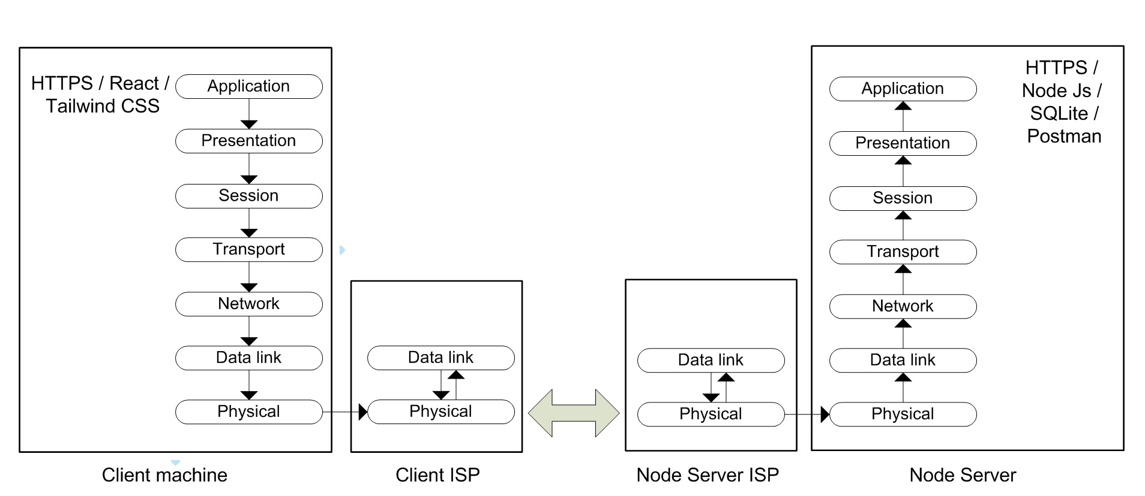

Figure Network Connectivity diagram

The above diagram illustrates a simple communication message flow from React / HTTPS to Node / HTTPS.

User request (Request by React)is picked up by Client machine Application layer. The message then travels through 7 layers (layer 7 to layer1) of Client machine and reaches Client ISP.

Client ISP sends the message to Node Server ISP through routing table.

User request (from React) then travels from Node Server (ISP) to Node Server.

Then finally, the message (Client request from React) travels (from layer 1 to layer 7) to Application layer of Node Server.

Note: All messages from Client to Server (or from Server to Client) follow this above illustrated path.

# Planning and Research

## Resource and time allocation

Frontend and Frontend teams work concurrently to develop the application. There will be constant information exchange between Frontend team and Frontend team. The university has provided very good communication tool call Slack. Slack is used for every communication between the developers (Frontend as well as Backend).

The first two weeks were used by the team to get familiar with the tools / libraries / protocols / APIs. The team also spent time in knowing the capabilities of the tools. Some users were not familiar with the tools. The first two weeks used to get familiar the tool.

Though the first half of semester was used for the research; The first half of the semester mainly concentrated on market research, project options, project reasoning, project selection etc.

## Frontend

Frontend mainly concentrated on the dealing with end users. This involved

* Type of Frontend
* Tool used for the Frontend
* Size of every single screen
* Color scheme used for the user interface
* Font used for the Frontend
* Sequence of the screens
* Logic behind the screen

### Type of Frontend

This part of section deals with what kind of Frontend selected. To be specific Frontend planned to work in windows environment (windows 7, windows 10, windows 11). Frontend planned to work in Linux environment. And Frontend also planned to work with Apple Macintosh.

### Tools used for the Frontend

Tools were carefully selected to keep the system small and efficient.

Frontend selected is React with Tailwind CSS.

React works in conjunction with Tailwind CSS to give the best user experience. Frontend dynamically changes the Seat management and Institution screens based on the number of seats and size of the institution.

### Size of every single screen

While most of the screens are common size, some screens such as Institution screen and seat management screen varies based on the number of type of institution and number of seats available to reserve in the institution.

### Color scheme used for the user interface

All the screens have white background.

Screen where user input is required is with white background and black text. Default texts are displayed in grey color.

Every screen has preferred user action; this type of buttons is with Purple button.

Screen with Registration, Confirm seat are displayed in Black color.

Seats to be Added / add Confirm are with Green button.

Seats to be Deleted are with Red button.

Seats to be Moved / Edited are with Blue button.

### Font used for the Frontend

Default font is managed by “fonts.googleapis.com/css2” this font changes based on the global setting.

### Sequence of the screens

Every client opens with ‘Welcome to SpaceWise’ screen.

Based on the user (Admin or Student) screens will go to respective area of operation.

#### Student screens

* Register (register.html)
* Login (login.html)
* Select a Library (institutionSelection.html)
* Manage Space Details (seatManagament.html)
* Manage Reservations (reservationManagement.html)
* My Reservations (reservationSelection.html)
* Select a Seat (seatSelection.html)
* Select a Space (spaceSelection.html)
* Student Home (studentHome.html)

#### Administrators screen

* Register (register.html)
* Admin Dashboard (adminHome.html)
* Manage your Institution (institutionManagement.html)
* Login (login.html)
* Manage Spaces (spaceManagement.html)

### Logic behind the screen

Depending in the user type (Administrator or Student) screens are divided into two main category (refer to previous section – Sequence of the screens for more details on the screens).

#### Administrator’s Screens

* Administrators will be able to create/delete Institute using “Manage your Institution” screen.
* Administrators will be able to create/delete Space using “Manage Spaces” screen.

#### Students Screens

Upon startup students will be greeted with Login screen.

New student will go to Register screen (student will not get another option until registering).

#### Student Home page

Registered students will be directed to “Student Home” page.

#### Student Reservation

Upon registering students will be able to book either “Co-Working Space” or “Library Space” for their booking. Or Students will go to “Manage Reservations” to Cancel their reservation.

* Student then have to select “Select a Space”.
* After selecting Space Student will then be able to reserve a seat through “My Reservations”.

#### Student Cancel Reservations

* Student will have to select “Manage Reservations” from “Student Home” page.

## Backend

Backend holds and manages all the data. It serves Frontend’s request for data and also saves Frontends data.

### Tools used for the Backend

Following are the Software and Tools used for Backend

Node JS – Main operating System for Server

SQLite database – Database to serve front end’s requests

Espress JS – API requests to node

Postman – Testing tool for SQLite database (in lieu of Frontend)

MS Studio Code – Microsoft Studio code is the editor / IDE used for Programing

NPM – package manager

### Size of screen

There is no screen size for Backend tools. Developer is free to use the screen size of choice.

### Color scheme used for the user interface

Backend tools don’t use color schemes. Developer is free to use the screen size of choice.

## Database Tables

institution_admins

|  |  |  |  |  |  |
| --- | --- | --- | --- | --- | --- |
| **Column** | **Type** | **Comment** | **PK** | **Nullable** | **Default** |
| admin_id | int |  | YES | NO |  |
| institution_id | int |  |  | NO |  |

institutions

|  |  |  |  |  |  |
| --- | --- | --- | --- | --- | --- |
| **Column** | **Type** | **Comment** | **PK** | **Nullable** | **Default** |
| institution_id | int |  | YES | NO |  |
| name | varchar(100) |  |  | NO |  |
| bio | text |  |  | YES |  |
| address | varchar(255) |  |  | NO |  |
| opening_hours | varchar(50) |  |  | YES |  |
| admin_id | int |  |  | NO |  |

reservations

|  |  |  |  |  |  |
| --- | --- | --- | --- | --- | --- |
| **Column** | **Type** | **Comment** | **PK** | **Nullable** | **Default** |
| reservation_id | int |  | YES | NO |  |
| space_id | int |  |  | NO |  |
| seat_id | int |  |  | NO |  |
| user_id | int |  |  | NO |  |
| start_time | datetime |  |  | NO |  |
| end_time | datetime |  |  | NO |  |
| status | enum('active','expired','cancelled') |  |  | NO |  |

seats

|  |  |  |  |  |  |
| --- | --- | --- | --- | --- | --- |
| **Column** | **Type** | **Comment** | **PK** | **Nullable** | **Default** |
| seat_id | int |  | YES | NO |  |
| space_id | int |  |  | NO |  |
| name | varchar(50) |  |  | NO |  |
| type | varchar(50) |  |  | YES |  |
| facilities | json |  |  | YES |  |
| status | enum('available','reserved','unavailable') |  |  | NO |  |

spaces

|  |  |  |  |  |  |
| --- | --- | --- | --- | --- | --- |
| **Column** | **Type** | **Comment** | **PK** | **Nullable** | **Default** |
| space_id | int |  | YES | NO |  |
| institution_id | int |  |  | NO |  |
| name | varchar(100) |  |  | NO |  |
| layout | text |  |  | YES |  |

students

|  |  |  |  |  |  |
| --- | --- | --- | --- | --- | --- |
| **Column** | **Type** | **Comment** | **PK** | **Nullable** | **Default** |
| student_id | int |  | YES | NO |  |

users

|  |  |  |  |  |  |
| --- | --- | --- | --- | --- | --- |
| **Column** | **Type** | **Comment** | **PK** | **Nullable** | **Default** |
| user_id | int |  | YES | NO |  |
| username | varchar(50) |  |  | NO |  |
| password_hash | varchar(255) |  |  | NO |  |
| role | enum('admin','student') |  |  | NO |  |

## UML – Table relations

Following is a UML representation of relationship between tables.

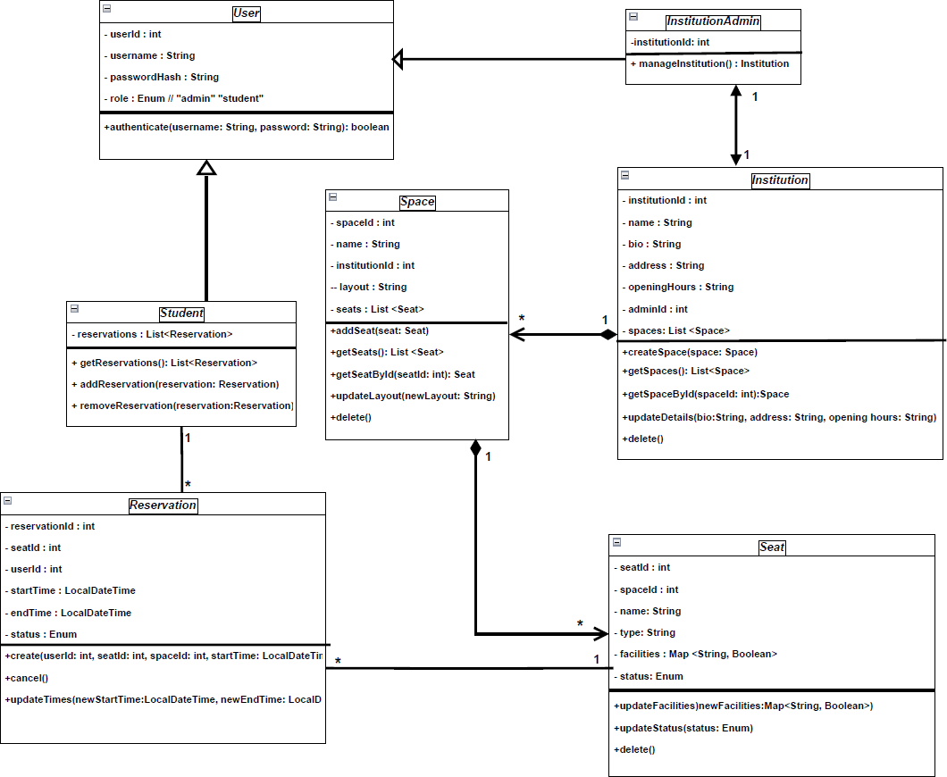

Figure UML representation of relationship of Tables

## REST – API pseudo code

**Authentication**

* **POST /auth/register**
  + **Register a new user or admin.**
  + **Input:**

**{**

**"username": "admin123",**

**"password": "securepassword",**

**"role": "admin" // or "student"**

**}**

* **Output:**

**{**

**"user_id": 1,**

**"message": "User registered successfully."**

**}**

**Query:**

INSERT INTO users (username, password_hash, role)

VALUES (

  'admin123', 'securepassword', 'admin'

);

SELECT user_id FROM users WHERE username = 'admin123';

* **POST /auth/login**
  + **Authenticate student/admin and return a token.**
  + **Input:**

**{**

**"username": "admin123",**

**"password": "securepassword"**

**}**

* **Output:**

**{**

**"token": "jwt_token",**

**"user_id": 1,**

**"role": "admin"**

**}**

**Query:**

SELECT user_id, role

FROM users

WHERE username = 'admin123' AND password_hash = 'securepassword';

**Institution Management**

* **POST /institution/register**
  + **Creates an institution and links its admin.**
  + **Input:**

**{**

**"institution_name": "Library Central",**

**"bio": "Main library of the city",**

**"address": "123 Library Street",**

**"opening_hours": "9 AM - 8 PM",**

**"admin_id”: 1**

**}**

* **Output:**

**{**

**"institution_id": 1,**

**"message": "Institution registered successfully."**

**}**

INSERT INTO institutins (institution_id, bio, address, opening_hours, admin_id)

VALUES (1, 'Library Central', 'Main library of the city', '9 AM - 8 PM', 1);

SELECT institution_id FROM institutions WHERE name = 'Library Central';

* **GET /institutions**
  + **Retrieve a list of all institutions.**
  + **Output:**

**[**

**{**

**"institution_id": 1,**

**"institution_name": "Library Central",**

**"bio": "Main library of the city",**

**"address": "123 Library Street",**

**"opening_hours": "9 AM - 8 PM"**

**},**

**{**

**"institution_id": 2,**

**"institution_name": "Co-working Space A",**

**"bio": "Modern space for startups",**

**"address": "456 Startup Lane",**

**"opening_hours": "24/7"**

**}**

**]**

SELECT institution_id, name, bio, address, opening_hours FROM institutions;

* **GET /institutions/:id**
  + **Retrieve details of a specific institution.**
  + **Output:**

**{**

**"institution_id": 1,**

**"institution_name": "Library Central",**

**"bio": "Main library of the city",**

**"address": "123 Library Street",**

**"opening_hours": "9 AM - 8 PM",**

**"admin_username": "admin123"**

**}**

SELECT i.institution_id, i.name, i.bio, i.address, i.opening_hours AS admin_username

FROM institutions i

JOIN institution_admins ia ON i.institution_id = ia.institution_id

JOIN users u ON ia.admin_id = u.user_id

WHERE i.institution_id = 1;

* **PATCH /institutions/:id**
  + **Update institution details.**
  + **Input:**

**{**

**"bio": "Updated bio for the institution",**

**"address": "New Address Street",**

**"opening_hours": "8 AM - 6 PM"**

**}**

* **Output:**

**{**

**"message": "Institution details updated successfully."**

**}**

UPDATE institutions

SET bio = 'Updated bio for the institution',

    address = 'New Address Street',

    opening_hours = '8 AM - 6 PM'

WHERE institution_id = 2;

* **DELETE /institutions/:id**
  + **Delete the institution and its data.**
  + **Output:**

**{**

**"message": "Institution deleted successfully."**

**}**

DELETE FROM institutions WHERE institution_id = 1;

**Space Management**

* **POST /institutions/:id/spaces**
  + **Create a space for a specific institution and upload a layout image.**
  + **Input:**

**{**

**"name": "Library Room A",**

**"layout_image": "base64_encoded_image"**

**}**

* **Output:**

**{**

**"space_id": 5,**

**"message": "Space created successfully."**

**}**

INSERT INTO spaces(name, layout)

VALUES (

    'Library Room A', 'base64_encoded_image'

);

SELECT space_id FROM spaces WHERE name = 'Library Room A' AND institution_id = 1;

* **GET /institutions/:id/spaces**
  + **Retrieve all spaces for a specific institution.**
  + **Output:**

**[**

**{**

**"space_id": 5,**

**"name": "Library Room A",**

**"layout_image": "https://example.com/uploads/room-a.png"**

**},**

**{**

**"space_id": 6,**

**"name": "Library Room B",**

**"layout_image": "https://example.com/uploads/room-b.png"**

**}**

**]**

SELECT space_id, name, layout FROM spaces WHERE institution_id = 1;

* **GET /institutions/:id/spaces/:spaceId**
  + **Retrieve details of a specific space, including the layout image.**
  + **Output:**

**{**

**"space_id": 5,**

**"name": "Library Room A",**

**"layout_image": "https://example.com/uploads/room-a.png"**

**}**

SELECT space_id, name, layout FROM spaces WHERE institution_id = 1 AND space_id = 1;

* **PATCH /institutions/:id/spaces/:spaceId**
  + **Update space details and/or replace the layout image.**
  + **Input:**

**{**

**"name": "Updated Room Name",**

**"layout_image": "base64_encoded_image"**

**}**

* **Output:**

**{**

**"message": "Space details updated successfully."**

**}**

UPDATE spaces

SET name = 'Updated Room Name',

    layout = 'updated.png'

WHERE institution_id = 2 AND space_id = 3;

* **DELETE /institutions/:id/spaces/:spaceId**
  + **Delete a specific space.**
  + **Output:**

**{**

**"message": "Space deleted successfully."**

**}**

DELETE FROM spaces WHERE institution_id = 1 AND space_id = 2;

**Seat Management**

* **POST /institutions/:id/spaces/:spaceId/seats**
  + **Add seats to a specific space within an institution.**
  + **Input:**

**{**

**"seat_name": "A1",**

**"type": "Chair",**

**"facilities": ["Outlet", "Lamp"],**

**"status": "Available"**

**}**

* **Output:**

**{**

**"seat_id": 101,**

**"message": "Seat added successfully."**

**}**

INSERT INTO seats (space_id, name, type, facilities, status)

VALUES (2, 'C2', 'Chair', '["Outlet", "Lamp"]', 'Available');

SELECT seat_id FROM seats WHERE name = 'C2' AND space_id = 2;

* **PATCH /institutions/:id/spaces/:spaceId/seats/:seatId**
  + **Update details of a specific seat (e.g., facilities, status).**
  + **Input:**

**{**

**"type": "Table",**

**"facilities": ["Outlet"],**

**"status": "Unavailable"**

**}**

* **Output:**

**{**

**"message": "Seat details updated successfully."**

**}**

UPDATE seats

SET type = 'Table',

    facilities = '["Outlet"]',

    status = 'Unavailable'

WHERE space_id = 3 AND seat_id = 4;

* **DELETE /institutions/:id/spaces/:spaceId/seats/:seatId**
  + **Remove a specific seat.**
  + **Output:**

**{**

**"message": "Seat deleted successfully."**

**}**

DELETE FROM seats WHERE space_id = 1 AND seat_id = 1;

**Reservation Management**

* **POST /reservations**
  + **Create a reservation for a seat.**
  + **Input:**

**{**

**"seat_id": 101,**

**"user_id": 42,**

**"start_time": "2024-12-22T09:00:00Z",**

**"end_time": "2024-12-22T11:00:00Z"**

**}**

* **Output:**

**{**

**"reservation_id": 201,**

**"message": "Reservation created successfully."**

**}**

INSERT INTO reservations (space_id, seat_id, user_id, start_time, end_time, status)

VALUES (2, 2, 1, '2025-02-02 9:00', '2025-02-02 12:30', 'Active');

* **GET /reservations/:student_id**
  + **Retrieve all reservations for a specific user.**
  + **Output:**

**[**

**{**

**"reservation_id": 201,**

**"seat_id": 101,**

**"seat_name": "A1",**

**"start_time": "2024-12-22T09:00:00Z",**

**"end_time": "2024-12-22T11:00:00Z",**

**"status": "Active"**

**},**

**{**

**"reservation_id": 202,**

**"seat_id": 102,**

**"seat_name": "B1",**

**"start_time": "2024-12-23T14:00:00Z",**

**"end_time": "2024-12-23T16:00:00Z",**

**"status": "Canceled"**

**}**

**]**

SELECT r.reservation_id, r.seat_id, r.start_time, r.end_time, r.status

FROM reservations r

JOIN seats s ON r.seat_id = s.seat_id

WHERE r.user_id = 2;

* **PATCH /reservations/:id**
  + **Update the time or status of a reservation.**
  + **Input:**

**{**

**"start_time": "2024-12-22T10:00:00Z",**

**"end_time": "2024-12-22T12:00:00Z",**

**"status": "Active"**

**}**

* **Output:**

**{**

**"message": "Reservation updated successfully."**

**}**

UPDATE reservations

SET

    start_time = COALESCE('2025-01-02 9:30', start_time),

    end_time = COALESCE('2025-01-02 12:30', end_time),

    status = COALESCE('Cancelled', status)

WHERE reservation_id = 3;

* **DELETE /reservations/:id**
  + **Cancel a reservation.**
  + **Output:**

**{**

**"message": "Reservation canceled successfully."**

**}**

UPDATE reservations

SET status = 'Cancelled'

WHERE reservation_id = 4;

## Interface Diagram of Frontend and Backend modules

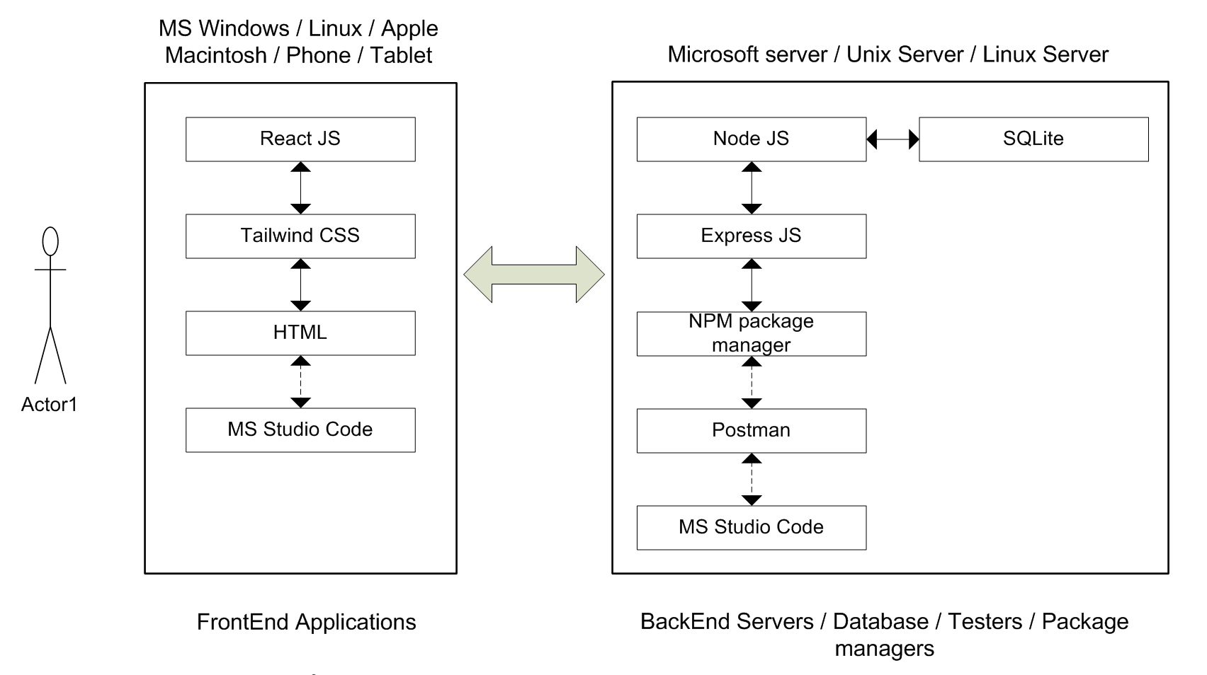

Figure Interface Diagram of FrontEnd and BackEnd modles

# User Experience (UX)

Frontend deals with user experience. Many measurable tasks with Frontend of our application.

* All the screens have responsive behavior. Same application can run in iPhone / Tablet / Android / Desktop / Laptop / Windows / Apple Macintosh / Linux etc. The application resizes to different size screens yet functions remain the same.
* Application designed considering color blind people. Most of color blind have either Bed color blindness or some have blue color blindness. So CSS does not select RED (255,0,0) or BLUE (0,0,255). Some buttons such as Delete must be in red color; this type of button has been selected as bg-red-600 (bg-red-800 while hovering). Some buttons such as Edit must be in blue color; this type of button has been selected as bg-blue-600 (bg-blue-800 while hovering).
* Application has been designed with good fonts from Google. All the fonts have reference to “https://fonts.googleapis.com/css2” and this font has been tested by Google for best performance and readability.
* Rounded edge buttons, forms, screens make more modern appeal.
* Some Elements such as bio in the screen institutionManagement tales multiple lines as input. This screen starts with minimum height and based on the number of characters entered and the screen size the dialog box automatically changes the height of the text box.
* Since the font and buttons are standard from Google. Adoption arte will be more than 60% (for young and old users).

# Testing of SpaceWise

## Whitebox testing

## Blackbox testing

## References

1. **Slack. (n.d.).** *Collaboration Made Simple.* Retrieved from [https://slack.com](https://slack.com/)
2. **Google Forms. (n.d.).** *Create and Analyze Surveys for Free.* Retrieved from <https://www.google.com/forms>
3. **Figma. (n.d.).** *Collaborative Interface Design Tool.* Retrieved from [https://www.figma.com](https://www.figma.com/)
4. **GitHub. (n.d.).** *Version Control and Collaboration.* Retrieved from [https://github.com](https://github.com/)
5. **ISO. (201G).** *ISO 8c01:2004 Data elements and interchange formats — Information interchange — Representation of dates and times.* Retrieved from <https://www.iso.org/>
6. **StackOverflow. (n.d.).** *Ǫuestions on API and HTTP Protocols.* Retrieved from <https://stackoverflow.com/>
7. **Academia. (n.d.).** *The Role of Structured Learning Environments.* Retrieved from [https://www.academia.edu](https://www.academia.edu/)

# Appendix – Meeting logs

18th January: Discussed the Second phase time lines. Discussed the skill gaps of the team. Discussed what skills are need for every individual to reach the team’s final goal of project completion in time.

-Learning of Tailwind CSS

-Learning of React JS

-Learning of SQLite

-Learning of Express JS

25th January: Discussed overview of the architecture of SpaceWise project.

Discussed about Frontend technology. Tools to be used for the Frontend. Discussed about Backend technology. Tools required for Backend.

1st February: Backend CURD operations table was referred from mid-term submission. Routing tables were built. Backend technology Node-js and SQLite were discussed. Frontend technology React was discussed.

8th February: Routing tables were finalized. Java script for routing table and REST API were finalized. Poastman tool was used to test the Backend. Frontend REACT and TAILWIND CSS were checked for their operation.

-Learning of postman

15th February:

Testing of Frontend and Backend modules.

Whitebox testing of Frontend and Backend modules.

Blackbox testing of Frontend and Backend modules.

22nd February:

First spring run was done. First iteration was done with completion first set of tests.

1st March:

Second sprint run was done. Second iteration done with completion of second set of tests. Kan ban board updated.

8th March: Finalizing of the SpaceWise application. Final touch to Frontend / Backend modules. Final integrated testing (prior to submission) done. Documentation checked for errors, formatting and consistency. Application and Document was finalized.

10th March: Final meeting before submission, Checked all the deliverables. Submitted the document.